SHRI SANT GAJANAN MAHARAJ

COLLEGE OF ENGINEERING SHEGAON, MH – INDIA (444 203)

TEAM
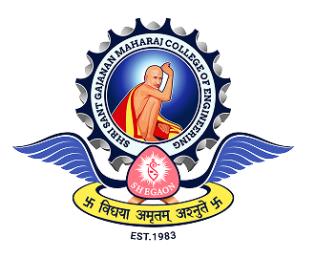
Biosensing, Microsystems &
Intelligent Diagnostics Lab (BioMID Lab)

Head of the Lab
Dr. Manish Bhaiyya
Research Associate
SGIARC

TEAM INFORMATION

NAME | Atharv Vishal Sadavarte
PROJECT NAME | Brain Tumor Detection and Classification Using Deep Learning
PROJECT DESCRIPTION | Developed a deep learning-based brain tumor detection and classification system using MRI images, employing transfer learning, advanced preprocessing, augmentation, and explainable AI techniques for accurate multi-class tumor classification.
CONTACT | SSGM_308103@ssgmce.ac.in



NAME | Kamran Ali
PROJECT NAME | Explainable AI for Atrial Fibrillation Detection Using 12-Lead ECG
PROJECT DESCRIPTION | Developed a deep learning system for automated detection of Atrial Fibrillation from 12-lead ECG signals.  The project uses a 1D U-Net architecture to learn important patterns from ECG recordings.  The workflow includes ECG preprocessing, model training, validation, testing, and performance evaluation.  Grad-CAM is used to explain the model's predictions by highlighting important regions of the ECG signal.
CONTACT | SSGM_309077@ssgmce.ac.in

NAME | Piyush Dawange
PROJECT NAME | Known and Unknown Crop Diseases Recognition
PROJECT DESCRIPTION | Currently working as an intern at Biospectronics, contributing to an AI-based agricultural crop disease detection project focused on crops prevalent in Maharashtra and India. The project involves leveraging Artificial Intelligence and Machine Learning techniques to detect and classify crop diseases from plant images, supporting smarter and more efficient agricultural practices.
CONTACT | SSGM_308608@ssgmce.ac.in


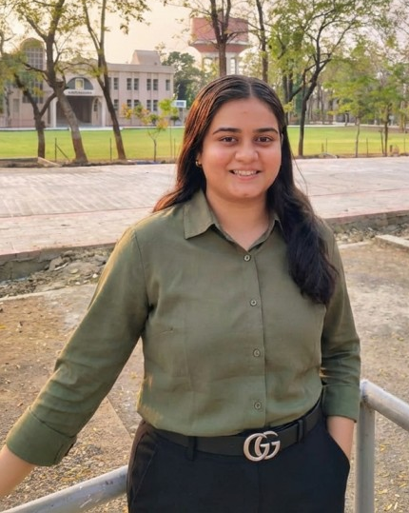
NAME | Tanushri Pravin Khawale
PROJECT NAME | Explainable Oral Cancer Recognition Using Informed Deep Learning and Case-Based Reasoning
PROJECT DESCRIPTION | Developing an explainable AI-based system for oral cancer recognition from clinical images. The proposed approach integrates IDL with medical knowledge and CBR to provide visual explanations through similar past cases. The system is designed to handle imperfect images and improve the transparency and reliability of oral cancer screening.
CONTACT | SSGM_308675@ssgmce.ac.in

NAME | Ummehani Sayyad
PROJECT NAME | Arrhythmia detection using Self-Supervised learning In both In distribution and out of distribution settings
PROJECT DESCRIPTION | Comparing SimCLR, BYOL and SwAV Self-Supervised learning methods in both ID and OOD settings and detect the arrhythmia.
CONTACT | SSGM_308677@ssgmce.ac.in


NAME | Ritika Manojkumar Chaudhari
PROJECT NAME | Alzheimer's Disease Detection Using CNN Optimized with Particle Swarm Optimization (PSO) on MRI Images
PROJECT DESCRIPTION | This project focuses on detecting Alzheimer's disease from MRI brain images using deep learning. A Convolutional Neural Network (CNN) is used for image classification, while Particle Swarm Optimization (PSO) is used to optimize the CNN architecture and improve its performance. The project also compares different deep learning models to achieve accurate and reliable detection..
CONTACT | SSGM_309044@ssgmce.ac.in
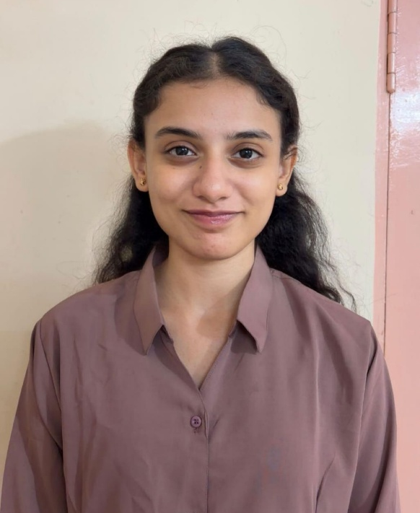

 | Dr. Manish Bhaiyya
Principal Investigator, BioMID Lab
Shri Sant Gajanan Maharaj College of Engineering, Shegaon, India

Dr. Manish Bhaiyya is an Associate Professor in the Department of Electronics and Telecommunication Engineering and the Principal Investigator of the BioMID Lab, where he leads interdisciplinary research at the convergence of biosensors, micro/nanotechnology, point-of-care diagnostics, and artificial intelligence.

He received his Ph.D. from BITS Pilani and subsequently carried out postdoctoral research at the Technion – Israel Institute of Technology, Israel. His research interests include portable and smartphone-integrated biosensing systems, electrochemiluminescence and chemiluminescence sensing, MEMS and microfluidic devices, micro/nanofabrication, functional sensing interfaces, and AI/ML-assisted biomedical diagnostics.

A major focus of his research is the development of portable, affordable, intelligent, and clinically relevant diagnostic technologies capable of translating complex biological signals into actionable information. His group particularly explores the integration of advanced sensing platforms with machine learning, deep learning, and data-driven decision-making for healthcare, disease screening, food safety, and real-world point-of-care applications.

Dr. Bhaiyya has authored more than 60 peer-reviewed publications in international journals spanning biosensing, analytical chemistry, biomedical engineering, micro/nanosystems, sensors, and artificial intelligence. His research has appeared in journals published by leading scientific publishers including ACS, Elsevier, Springer Nature, Wiley, IEEE, and others. He is also an inventor of patented electrochemiluminescence biosensing technology.

In addition to his research activities, Dr. Bhaiyya serves as an Associate Editor of Microsystem Technologies, a Springer Nature journal, contributing to the advancement and dissemination of research in microsystems, sensors, miniaturized devices, and emerging technologies.

Through the BioMID Lab, he aims to bridge the gap between materials and devices, sensing and intelligence, and laboratory innovation and real-world deployment, with a broader vision of developing next-generation intelligent diagnostic technologies that are accessible, scalable, and clinically meaningful.
CONTACT | manishbhaiyya@ssgmce.ac.in

NAME | Chetan Gajanan Itware
PROJECT NAME | Skin Cancer Detection & Classification
PROJECT DESCRIPTION | Developed a deep learning–based skin cancer detection application capable of classifying dermoscopic images into 7 skin-lesion classes.  The application provides the predicted class, confidence score, contributing factors/reasons, and precautionary recommendations to support user understanding.  Designed an end-to-end pipeline involving image preprocessing, augmentation, model training, performance evaluation, and external validation for robust skin-lesion classification.  Two research papers based on this work have been submitted for publication.
CONTACT | SSGM_308323@ssgmce.ac.in

NAME | Om Prashant Gond
PROJECT NAME | "A trustworthy multimodal AI for chest disease diagnosis and patient risk analysis "
PROJECT DESCRIPTION | "A trustworthy multimodal AI system for chest disease diagnosis and patient risk analysis using medical images and clinical data.  It combines X-ray analysis, patient metadata information to identify potential diseases and assess risk.  The system provides interpretable, confidence-aware predictions to support doctors in making safer and more informed clinical decisions."
CONTACT | SSGM_309393@ssgmce.ac.in


